

Dovecotes Tenant Management Organisation
86 Ryefield,
Dovecotes Estate
Pendeford
Wolverhampton
WV8 1UD

Invitation to Stand for Election to the Dovecotes TMO Board
Dear Resident,
We are pleased to invite you to take part in shaping the future of our community by standing to join the Dovecotes Tenant Management Organisation (TMO) Board. This is a fantastic opportunity to contribute to the improvement and development of the Dovecotes Estate and ensure that residents' voices are heard.
The Board is made up of local residents who volunteer their time to help manage housing services and community initiatives. If you care about where you live and want to make a difference, we encourage you to consider joining us.
What’s involved?
As a Board Member, you will help guide decisions on housing management, community safety, and local improvements. You’ll work alongside other committed residents and professionals to make Dovecotes a better, safer, and more vibrant place to live.
How to apply:
Please complete the attached Board Election Nomination Form and return it to the Dovecotes TMO office. You will need to include a short statement about yourself and why you would be a suitable candidate to become a member of the board.
If you have any questions or would like to learn more about what being a Board Member involves, feel free to contact us at the office or via email.
We look forward to receiving your nomination and thank you for your interest in supporting our community.
Warm regards,
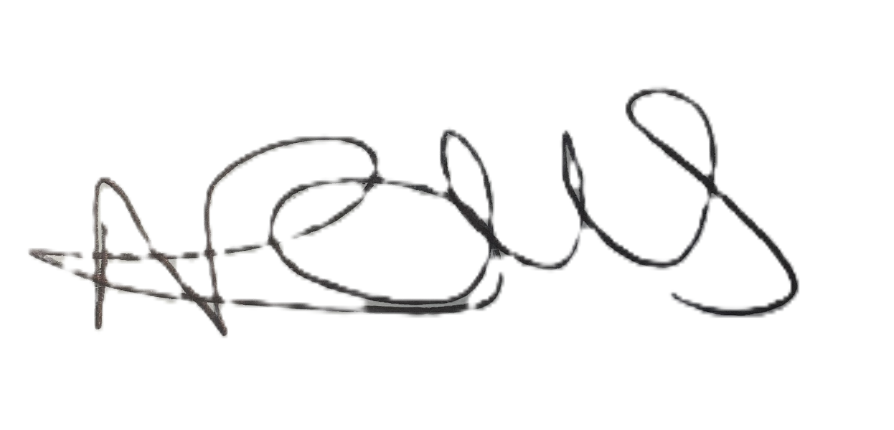
Nikki Rolls
Chief Officer
Dovecotes Tenant Management Organisation
Dovecotes TMO AGM Board Election Nomination Form
To be filled in by any resident in the Dovecotes area who wishes to stand for election to the Board (voluntary Management Committee) of Dovecotes TMO limited. This form needs to be submitted by Thursday 2 October.

Election Year: _

Resident Information
- Full Name:
- Email Address:
- Phone Number:
- Current Position/Title (existing board members only):

Membership Number:

Candidate Statement
Please say a little bit about yourself and why you would like to join the Management Board. The reason(s) why I want to stand for the Resident Management Committee are as follows: (this could be any relevant skills and experience you can bring to the board, work experience, other voluntary activities and/ or your knowledge of the local community). How can you help make Dovecotes a better, safer place where people want to live. No more than 500 words. (Please note this statement may be circulated during the ballot at the AGM).

Declaration and Consent
I have the following skills/experience that I believe will be useful on the Board:
I have read and understood the Rules the Dovecotes Tenant Management Organisation Limited and the Code of Conduct, and I understand the role and responsibility of Board members. I know of no reason why I may not stand for election to the board.

- ☐ I confirm that I agree to be stand for election and I am willing to serve if elected.
- ☐ I understand that submission of this form does not guarantee election to the board.

Signature of Nominee: _
Date: _

Once completed please return to Dovecotes TMO office.

